Infinite Campus Basic Navigation
2013
Brenda Miller
Natrona County School District #1
07/2013

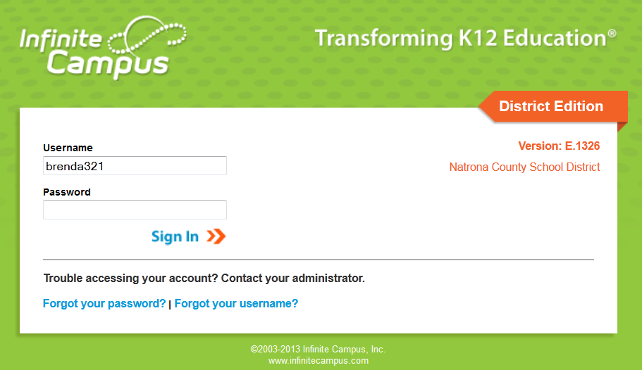

To login to Infinite Campus go to:
Natronaschools.org > Employees > Infinite Campus Login
Enter your Username and Password

Basic overview of Infinite Campus after you login.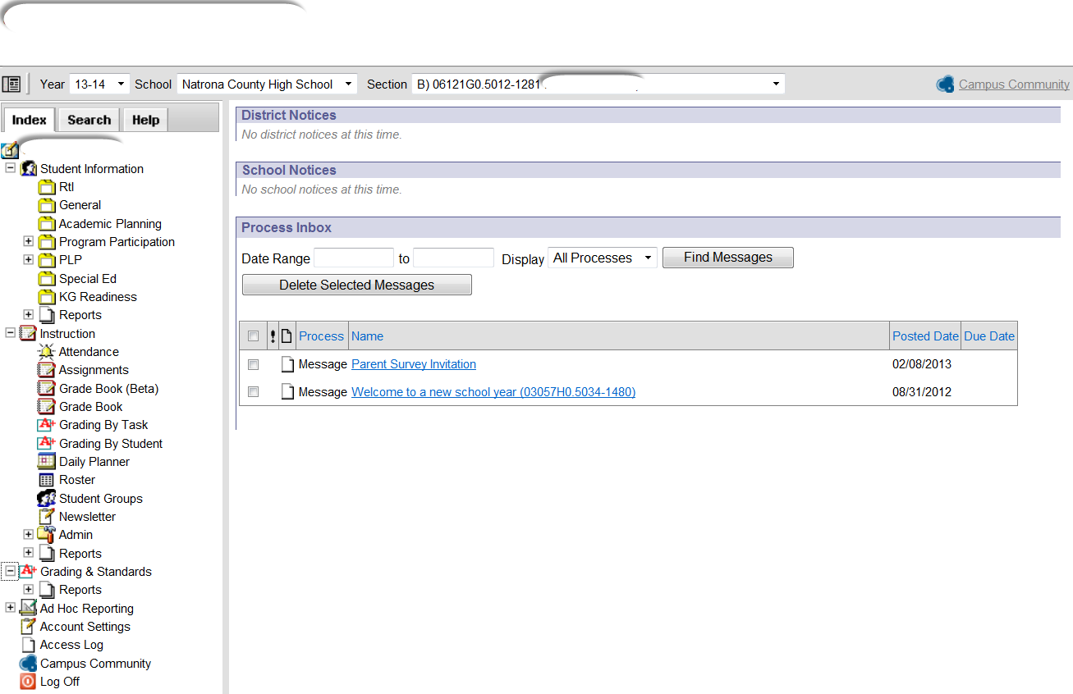

*************************************************************************************
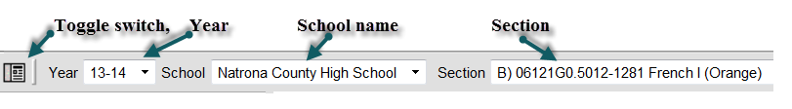
Toggle switch - when clicked it will hide the Index outline and give you more screen area to view
Year – is a list of the years
School Name – is a list of schools you attend for the current school year
Section – is a list of sections you teach during the current school year

*************************************************************************************

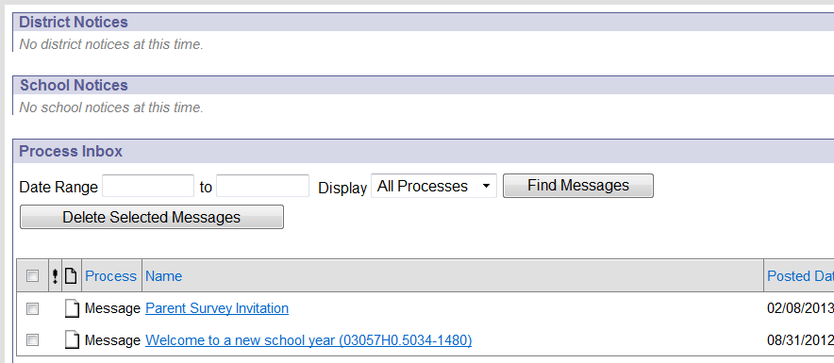

District & School Notices - User Notices provide a way to announce upcoming events, the daily school bulletin, district happenings, etc. Any user that logs into the Campus application will see the user notices. Portal users can also view user notices if the district so chooses.
Process Inbox - The Process Inbox is the message center for all system notifications relevant to a user of the Campus application. Notifications appearing in the Process Inbox are tailored to the currently logged-in user and are based on system activities related to the user and his/her tool rights.

*************************************************************************************

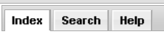

Index – Is an outline which provides a summary of each module within Infinite Campus.
Search - A user's tool and calendar rights greatly affect the options available in the Search For A field, as well as the results returned by the search. For example, a teacher may only have rights to search for students currently scheduled in the course sections that he/she teaches -- but would not have rights to search options like All People, User, and Address etc.
Help - Infinite Campus provides Help articles for every tool within Campus. By selecting the icon, users are directed to the Knowledge Base article about that tool and can review the product documentation. Access to other areas of the Community is available from the Knowledge Base article.

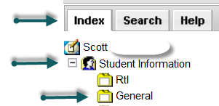

INDEX > Student Information > General >it will automatically ask to search for a student. Just click the word GO and all the students you are assigned to will drop down sorted by last name

*************************************************************************************

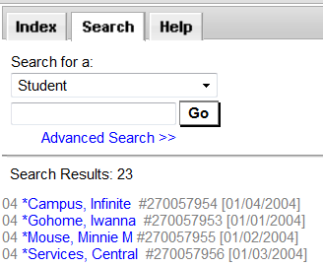

. Student names that are in blue are ACTIVE, student names that are in red are INACTIVE. In this list it will provide student grade, last name, first name, student ID #, and date of birth.

*************************************************************************************

If you click on a particular student name it will drill down more specific information about that student. Across the top of the screen, above the tabs, it will show the students name, grade, student ID #, Date of Birth, gender and nickname. The student may have program flags next to their name which indicate a way of labeling students for things such as food allergies, contact restrictions and/or specific learning programs.

*************************************************************************************

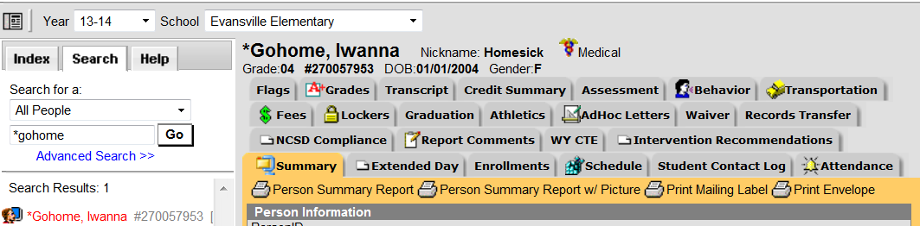

Summary tab - is a read-only tab and provides a quick look at student demographic data.
Enrollments – displays all occurrences of a student’s enrollment in the district.
Schedule - The schedule tab allows users to view and print the student's scheduled courses in multiple formats. The student's schedule is used to find where the student is during the day, can be used to determine which courses the student should be taking in future years and can be used to print the student's schedule.
Student Contact Log - allows team members to list when a student was in a conference, when contact was made to a parent or guardian, when the student was seen by staff member, or any other important contact made regarding the student’s health, counselor visits or discussions and learner planning notes.
Transportation - The student Transportation tab provides a space for users to record a student's transportation information. From here, users are able to define a student's bus stop(s), bus(es) used during the school day, typical bus arrival/departure times and the number of miles transported per day.
Fees - The Fees tab lists all transactions that have been assigned to a person, including all payments, adjustments, balance and existing surplus. If a person has reached the maximum fee amount established by the school and/or district,
Lockers - The student Locker tab defines and stores the locker's number, serial number, combinations, type and location.
Attendance - This information is given both at the detail level for each day. Summaries are available both by term and course. Attendance events are color-coded according to the key at the top of the tab.
Grades - lists the grades the student received for each grading task assigned to the course. These grades are added by teachers in the Grade Book or using the Grading by Task or Grading by Student tools in the Instruction module.
Transcript - The information listed on the transcript can vary from district to district depending on district preferences. Each district records grading information that students receive on transcripts and report cards.
Assessment - The district-level student Assessment tab is the main area for viewing, student test results.
Behavior - The Student Behavior tab provides a history of the student’s behavior events.

